Date: 13.05.2021
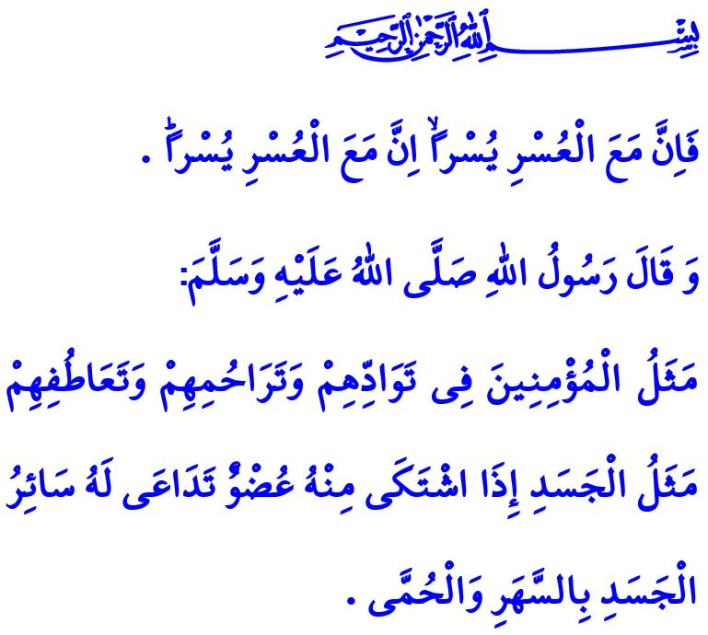
TOWARDS EIDS WHEN AL-QUDS IS FREE
Honorable Muslims!
We are experiencing a sour joy for Eid under the shadow of the pandemic disease this year, too, just like last year. This year, however, we are able to be together under the domes of great places of worship in this morning of Eid al-Fitr alhamdulillah. We pray to Allah (swt) for this Eid, which we will spend by observing the measures, to be the herald of more joyous eids. May this Eid be conducive to the fully opening of the gates of His (swt) help and assistance wide. May the verse, “For indeed, with hardship [will be] ease [i.e., relief]. Indeed, with hardship [will be] ease.” manifest itself for Muslims and all humanity.
Dear Believers!
Days of eid are the times to repair broken hearts and build bridges of friendship and affection. Let us avoid visits during this Eid, too, so as not to cause the spread of the pandemic and violate the rights of people. However, let us use the means of communication we have to exchange congratulations on Eid with our parents, friends, relatives, and neighbors, and ask how they are. Let us make them feel that we are there for them spiritually even if we are not able to be together. Let us view the days of Eid as opportunities to put an end to hard feelings and resentments between each other. Let us do our best not to lose the good habits we have acquired during Ramadan.
Dear Muslims!
We are saddened on Eid this year because al-Quds, sacred with its name and blessed with its surrounding, is wounded. We are witnessing an unruly and intimidating community’s barbarian assaults and attacks against the Masjid al-Aqsa and our Palestinian brothers and sisters. We are saddened on Eid this year because the occupiers, who disregard law, ethics, sacred values, violate the sanctity of al-Quds and its value for humanity. They martyr innocent lives, without discriminating children, the elderly or the women; block their entry into and exit from al-Quds; and prevent them from enjoying their freedom to worship in the Masjid al-Aqsa. The commandment of our Lord (swt), however, is very clear: “Who are more unjust than those who prevent the name of Allah from being mentioned [i.e., praised] in His mosques and strive toward their destruction? It is not for them to enter them except in fear. For them in this world is disgrace, and they will have in the Hereafter a great punishment.”
Dear Believers!
Al-Quds is a land of Islam that has been witnessing the most deeply rooted heritage of humanity. The Masjid al-Aqsa, the first qiblah of Islam, belongs to Muslims. The issue of al-Quds is a shared issue that concerns not only Palestinians, but also all Muslims. Today, too, just as in the past, our support and prayers are with our Palestinian brothers and sisters. For the sake of this Eid morning, may Allah the Almighty (swt) grant salvation to all oppressed people, and all victimized people forced out of their homes and lands. May He (swt) enable us to strengthen our spirit of being ummah and of brotherhood in faith. May He (swt) enable to us to see true days of Eid when al-Quds, the Masjid al-Aqsa, and all Islamic lands and places under occupation can freely celebrate. Eid Mubarak! I wish you all a happy Eid!
I would like to conclude this khutbah with the following hadith of the Prophet Muhammad (saw), “The similitude of believers in regard to mutual love, affection and fellow-feeling is that of one body; when any limb of it aches, the whole body aches because of sleeplessness and fever.”

Sharh, 94/5-6.
Baqarah, 2/114.
Muslim, Birr, 66. General Directorate of Religious Services

